

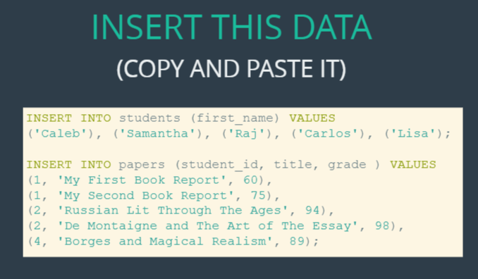

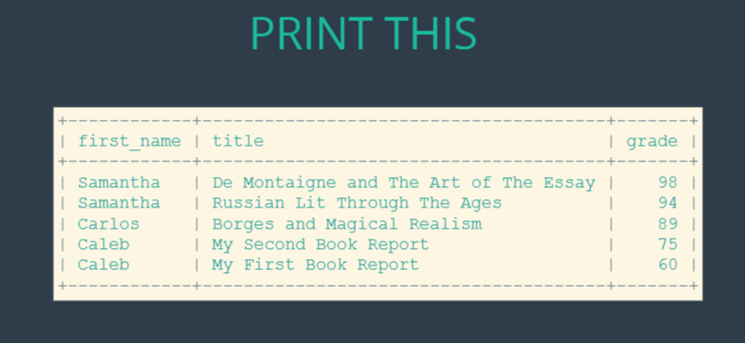





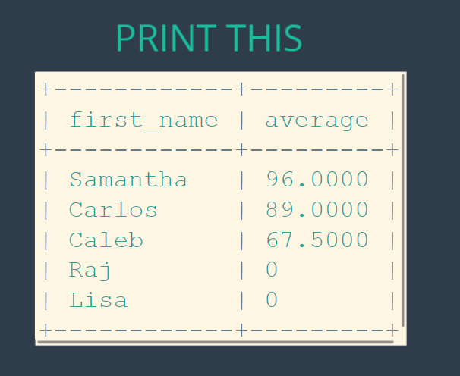

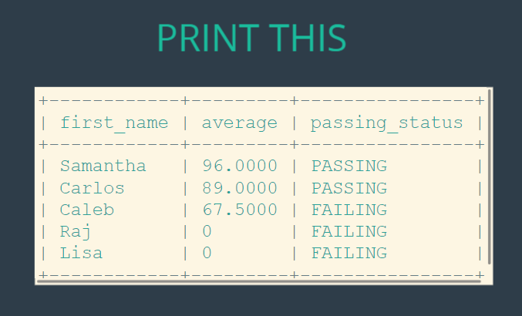

**The solutions:**

create database students;

use students;

create table students

(id int auto_increment primary key,

first_name varchar(100)

);

create table papers

(title varchar(100),

grade varchar(30),

student_id int,

foreign key (student_id) references students(id)

);

INSERT INTO students (first_name) VALUES

('Caleb'), ('Samantha'), ('Raj'), ('Carlos'), ('Lisa');

INSERT INTO papers (student_id, title, grade ) VALUES

(1, 'My First Book Report', 60),

(1, 'My Second Book Report', 75),

(2, 'Russian Lit Through The Ages', 94),

(2, 'De Montaigne and The Art of The Essay', 98),

(4, 'Borges and Magical Realism', 89);

select * from students;

select * from papers;

select first_name, title, grade from students

join papers on students.id = papers.student_id

order by grade desc;

select first_name, title, grade from students

left join papers on students.id = papers.student_id;

select first_name, ifnull(title, 'missing') as title, ifnull(grade, 0) as grade from students

left join papers on students.id = papers.student_id;

select first_name, ifnull(avg(grade), 0) as average from students

left join papers on students.id = papers.student_id

group by first_name

order by average desc;

select first_name, ifnull(avg(grade), 0) as average,

case

when ifnull(avg(grade), 0) > 80 then 'passing'

else 'failing'

end as passing_status

from students

left join papers on students.id = papers.student_id

group by first_name

order by average desc;